CS559 Midterm Exam
November 1, 2006

This exam is closed book and closed notes.

You will have the entire period (until 9:00pm) to complete the exam, although the exam is designed to take less time.

Please write your name and CS login on every page!

Write numerical answers in fractional form or use radicals (square root symbols) – we would prefer to see 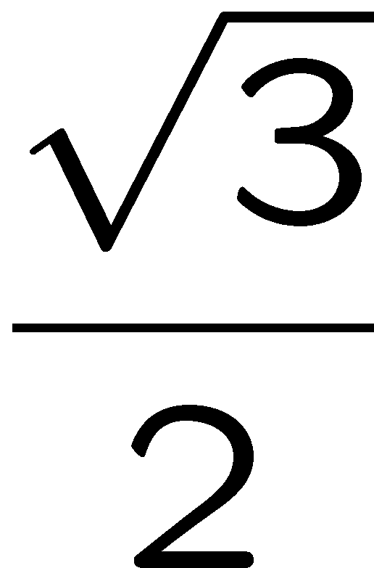than .866. You should not need a calculator for this exam.

Unless otherwise noted, assume that everything is a right-handed coordinate system and that angles are measured counter clockwise. E.g. to find the direction of rotation, point your thumb along the axis and curl your fingers.

If you need extra space, use the back of a page, but clearly mark what everything is. We may look at your work to determine partial credit.

For the short answer questions, concise answers will be rewarded. One or two sentences should do the trick.

Note: there are only 70 points on this exam (not 100).

Total: ___ / 70

Question 1: (4 Points)
Define metamer (in the sense used in graphics – it has another meaning in chemisty):

Question 2: (4 Points)
If Lightness is linearly coded between 0 and 255, is the difference between 100 and 101, or the difference between 200 and 201 more noticeable (perceptually)? Explain your answer.

Question 3: (8 Points)
A quadratic Bezier curve in 2D has its control points at (0,0), (6,6), and (12,0).
What are the control points for an identical cubic Bezier curve?

Question 4: (5 Points)
Which of the following things are artifacts from aliasing?
Note: there might be several things that are aliasing, so mark each one as either “A” for aliasing or “N” (for not).
___ A Zebra (black and white) appears gray in a resized picture
___ A Zebra appears all black in a resized picture
___ A small line disappears when a picture is resized
___ A small dark line becomes a fatter dim line when a picture is resized
___ A small black and white checkerboard pattern appears colorful when photographed with a digital camera.

Question 5: (6 Points)
For each of the properties, mark P if it is true of a perspective projection, O if its true of an orthographic projection, B if its true of both orthographic and projective, and N if its true of neither. (use P or O only if the property is only true of one type of transformation).
___ Straight lines are mapped to straight lines
___ Distances are preserved
___ Angles are preserved
___ An object can be viewed from its front, side or top
___ Far away objects appear the same size as closer ones
___ Requires homogeneous coordinates in order for it to be encoded into a linear transformation.

Question 6: (6 Points)
Let Aa be the alpha value from image A, Ac be the premultiplied color from image A, Ba be the alpha value from image B, and Bc be the premultipled color from image B. Assume alpha values range from 0 (totally transparent) to 1 (100% full, or fully opaque).
One useful compositing operation that we did not discuss in class is the “held-out” or “masked-by” operator. If we do A held-out B, we see A only in the places that B isn’t.
Derive an expression that computes the resulting premultiplied color and alpha value for A held-out B. Your answers should be expressions that use the values Aa, Ba, Ac and Bc.
Hint: consider what happens in the 4 overlap cases. You might want to make this clear in your work so we can give you partial credit in the event you get the final answer wrong.

Question 7: (7 Points)
Let the signal F be [ 3 3 6 9 3 9 3 3 9 ]
Let the kernel G be 1/3 [1 1 1] (assume that it is zero elsewhere)
Compute F convolved with G using reflection to handle the boundaries of F. Your answer should be a signal that is the same length as F.

Questions 8 and 9:
For the following questions, consider a simple graphics toolkit that works like OpenGL (that is, it has a matrix stack, and the transformation commands post-multiply themselves onto it):
Translate(x,y) – post-multiplies a translation matrix onto the top of the matrix stack
Rotate(a) – rotates (counter clockwise around the origin) by a degrees
Scale((x,y) – scales by x and y. BOTH X and Y MUST BE POSITIVE
ReflectY() – reflects around the Y axis (note: this changes the X positions)
Push() – pushes a copy of the top element on the matrix stack
Pop() – removes the top element from the matrix stack
Block(letter) – draws an “alphabet block” with the letter inside. The block is a unit square, with its lower left corner at (0,0) and its upper left corner at (1,1). You can assume that the letter A is symmetric about its vertical center, and the letters B, C, D and E are symmetric about their horizontal centers.

Here’s an example program and its output:
Push
Translate(2,2)
Block(‘A’)
Pop
Block(‘B’)

Question 8: (6 Points)
Notice that there is no “ReflectX” command to reflex about the X axis. Give a few lines of code (using the provided commands) that perform that function (of concatenating a reflection about the X axis on the stack). (note: the parameters for scale must both be positive, so that obvious solution is not allowed).

Question 9: (10 points)
Suppose the translate command was broken so that it only took values 0 or 1 for X and Y. (e.g. translate(1,0) or translate(1,1) or translate(0,1) work, but translate(2,0) would not).
Give the shortest program you can think of for drawing the following picture (You will get no points for a program that draws the wrong picture, and will be penalized for your program being longer than the shortest possible answer).

Question 10: (6 Points)
The Catmull-Rom Basis Matrix is:
0 | 1 | 0 | 0
-1/2 | 0 | ½ | 0
1 | -5/2 | 2 | -1/2
-1/2 | 3/2 | -3/2 | ½
A Catmull-Rom spline segment has its control points at (5 2/3,5 3/4), (10 1/2,10), (20 7/8,10), and (25 3/8,5).
What is the value of the spline at u=1?
What is the 1st derivative (a vector) at u=1?
Question 11: (2 Points)
Given a rotation matrix R and a translation matrix T, the composition R⁻¹TR is equivalent to:
a) A rotation
b) A translation
c) A shear
d) A scale
e) None of the above

Question 12: (2 Points)
What is the effect of transforming a 3D object by the following 4x4 matrix, assuming we are working in homogeneous coordinates?
$$\left[\begin{matrix}3 & 0 & 0 & 0 \\ 0 & 3 & 0 & 0 \\ 0 & 0 & 3 & 0 \\ 0 & 0 & 0 & 3\end{matrix}\right]$$ | a) Translates the object  b) Scales the object up  c) Scales the object down  d) Produces a perspective view of the object  e) Does nothing to the object

Question 13: (4 Points)
A robot designer creates a synthetic monkey with a vision system that is similar to a new
world monkey in that it has two types of photo receptors. The designer makes one type of
photoreceptor sensitive only to green light, and the other type only sensitive to red light.
The robot passes its tests for identifying bananas in pictures presented on the CRT screen
of the designer’s computer, but cannot find bananas in the jungle. Explain why this happened.

