CS559 Final Exam, December 21, 2007

Closed Book and Closed Notes.

You will have the entire exam period (until 4:45pm) to complete the exam.

Please write your name on every page!

Write numerical answers in fractional form or use radicals (square root symbols) – we would prefer to see 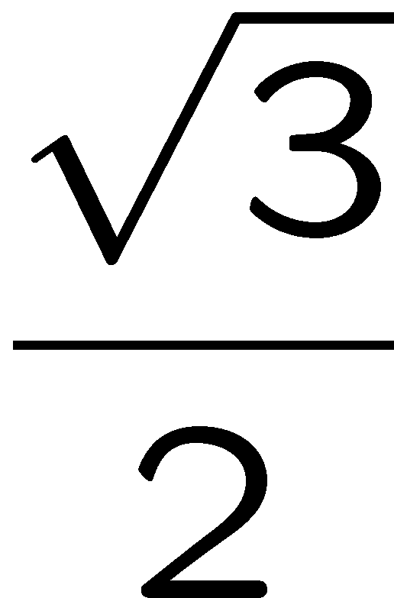than .866. You should not need a calculator for this exam.

Unless otherwise noted, assume that everything is a right-handed coordinate system and that angles are measured counter clockwise (i.e. to find the direction of rotation, point your thumb along the axis and curl your fingers).

Please keep your answers concise and readable. Answers that are excessively wordy or illegible will be considered incorrect. If you need more space, use the back of the page, but put a note telling us to look there.

There are 8 Questions on the exam.
Q1 __ / 8
Q2 __ / 8
Q3 __ / 6
Q4 __ / 30
Q5 __ / 12
Q6 __ / 6
Q7 __ / 16
Q8 __ / 14

Total Score ___ / 100

Question 1: Ray Tracing: (8 points)

A student has built a basic backwards (i.e. from-the-eye) Ray Tracer that works. They are considering adding extra features. For each of these features, describe what the advantage would be (what improvement would they get).

- A Binary Space Partition Tree

- More levels of recursion

Question 2: Ray Tracing (8 points)
Give 2 uses of distributed (or distribution) ray tracing:

1.

2.

Question 3: Non-Photo Realistic Rendering (6 points)

Give a reason why you might choose to do non-photorealistic rendering.

Question 4: Grading Exam Questions (30 points)

Here are some exam questions from another Computer Graphics exam, along with some students answers. For each answer, mark it correct or wrong. If you mark it wrong, give an explanation of why the answer is wrong. Sometime the answer is wrong because it is not necessarily true – in these cases, the best way to show its wrong is to give a counter-example.
(hint – this is basically true/false; except you have to explain the false)

(If you want to give a reason why you think the answer is right just in case you think your opinion is different than our, you can do that too – but its totally optional)

Example: Why might you prefer a Modified Butterfly Subdivision Scheme to a Catmull-Clark Scheme?
Example.1: Because you might want to interpolate your original vertices.
Correct
Example 2: Because you might need to know exactly where points on the resulting surface will end up.
Wrong – exact evaluation schemes exist for Catmull-Clark surfaces that will tell where points will end up on the limit surface.

A. Why are the lights in a tri-stimulus color system sometimes called “imaginary”?

A.1: Because they can create colors that can’t be seen in the real world (i.e. can only be seen in one’s imagination)

A.2: Because they involve negative amounts of energy at certain wavelengths.

B. A curve f(u) is arc-length reparameterized to create a new curve g(u). These curves are used as train tracks. A train moves along each curve with a constant rate of change of the parameter. What can you say about the velocity (in world space) about the trains?

B.1: The world space velocity of the train on track f will remain constant for the entire range of the motion.

B.2: The world space velocity of the train on track g will remain constant for the entire range of the motion.
(continued from Question 4.B on the previous page)
B.3.: The train on track f will definitely get to the end of the track before the train on track g.

B.4: The train on track g will go faster than the train on track f.

C. Name a compression scheme that may provide good compression on many (or even most) images, but cannot guarantee that the result will be compressed (i.e. there exist images for which the compressed version is not smaller than the original).

C.1: Ziv-Lempel (LZ) coding

C.2: JPEG

C.3: Run-length encoding

D. Name a technique that can be implemented in the Fragment (or sometimes called Pixel) shader of a modern graphics card.

D.1: Multi-Texturing

D.2: Bump Mapping

D.3: Displacement Mapping

E. Name a technique that can be implemented in the Vertex Shader of a modern programmable graphics card, assuming that the Fragment (or Pixel) Shader does the standard pipeline.

E.1 Phong Lighting

E.2 Phong Shading

F. Give an example of a scalar field

F.1: For every location on a piece of paper, we measure the intensity of the light

F.2: For every position on a map, we measure the altitude

F.3: For every position on a map, we give a vector that points to the nearest tree.

F.4: For every position in the space around the model of an airplane, we measure the air pressure.

F.5: For every position in the space around the model of an airplane, we have a vector that gives the direction and magnitude of the airflow at that point

F.6: For every position in the space around the model of an airplane, for every instant of time in its flight, we measure the air pressure.

Question 5: Subdivision (12 points)
A mesh is made up of two triangles, a hexagon (6 sides), and 100 quadrilaterals. All vertices in the mesh are connected to exactly 4 other vertices. The mesh is closed (it has no edges). (note: this mesh is hypothetical, I’m not sure it can actually exist, but that doesn’t matter for this question).

This mesh is used as the starting surface for Catmull-Clark Subdivision.

5A: After the first subdivision, how many polygons will not be quadrilaterals?

5B: After the first subdivision, how many vertices have less than 4 neighbors?

5C: After the first subdivision, how many vertices have more than 4 neighbors?

5D: Each time you subdivide after that, how does the number of vertices with more or less than 4 neighbors change?

Question 6: Environment Mapping (6 points)
Environment mapping can be used to simulate reflections in a standard scanline renderer.
It could be used for creating a mirrored Christmas tree ornament (a small shiny ball), or for making a large flat mirror like you’d hang on the wall.
Which one would it work better for, and why?

Question 7: Lighting (16 points)
Consider the following scene. A point light source L is placed at (0,10,0). The eye point is placed at (20,10,0). For this question, we’re only considering locations with Z=0. Assume we’re using the lighting model we discussed in class (what OpenGL does).

Consider the line on the floor from (0,0,0) to (20,0,0), and the brightness on that line caused by the light source. For each of the following lighting conditions, make a graph of the brightness for each X position from 0-20. Note: the actual values of the brightness don’t matter (in fact, you can’t know exactly what they are since we haven’t told you how bright things are, or the exact value of the specular exponent). However, you should be able to create a graph that is qualitatively correct (has the right shape, has the minima and maxima at the right places, …).

In some cases the floor is a single large polygon, and in other cases, the floor is two polygons, one that is (0,0,-5), (0,0,5), (10,0,5), (10,0,-5), and the other is (10,0,5), (10,0,-5), (20,0,-5), (20,0,5). That is, half of the line you’re considering (from 0-10) is on one polygon, while the other half (10-20) is on the other.

- The floor is a single large polygon. There is no ambient or specular lighting (their values are 0), but a large diffuse component, and Gouraud shading.
0
10
20
- The floor is made of 2 polygons (as described). There is no ambient or specular lighting (their values are 0), but a large diffuse component, and Gouraud shading.
- The floor is a single large polygon. There is no ambient or specular lighting (their values are 0), but a large diffuse component, and Phong shading..
- The floor is a single large polygon. There is no ambient or diffuse lighting, but there is a large specular component with a very large exponent. Use Gouraud shading.
- The floor is made of 2 polygons (as described above). There is no ambient or diffuse lighting, but there is a large specular component with a very large exponent. Use Gouraud shading.
- The floor is a single large polygon. There is no ambient or diffuse lighting, but there is a large specular component with a very large exponent. Use Phong shading.
- Exactly as part (F), but with a much smaller specular exponent. What we are looking for here is the difference between this situation and (F).
- How would the answer to part F change if the floor was made of 2 polygons?

Question 8: Polygon and Texture Drawing (14 points)
A single polygon (quadrilateral) has its four corner positions as:
(0,0,0), (0,.5,0), (.5,.5,0), (.5,0,0)
these vertices have the following texture coordinates
(.5,.5), (.7,.4), (.7,.8), (.5,.7)
The texture is a 10x10 checkerboard (so each square is .1x.1)
The polygon is drawn in Normalized Device Coordinates (NDC) – this is what OpenGL has if its two transformation matrices are both the identity. Lighting is turned off (texturing is turned on – so the color of a pixel is the color of the texture)

8A) Sketch what the screen would look like when this polygon is drawn:
You can assume that the viewport (window) is square, as shown in the picture. The lines are evenly spaced.

8B) describe how the answer to 7A would change if the Z values of the vertex positions were changed to:
(0,0,-.5), (0,.5,-.5), (.5,.5,-.5), (.5,0,-.5) (note: only the Z values have changed)
(if it is easier for you, you can sketch your answer)

8C) describe how the answer to 7A would change if the Z values of the vertex positions were changed to:
(0,0,-2), (0,.5,-2), (.5,.5,-2), (.5,0,-2) (note: only the Z values have changed)
(if it is easier for you, you can sketch your answer)

