CS559 Midterm Exam
November 1, 2006

This exam is closed book and closed notes.

You will have the entire period (until 9:00pm) to complete the exam, although the exam is designed to take less time.

Please write your name and CS login on every page!

Write numerical answers in fractional form or use radicals (square root symbols) – we would prefer to see 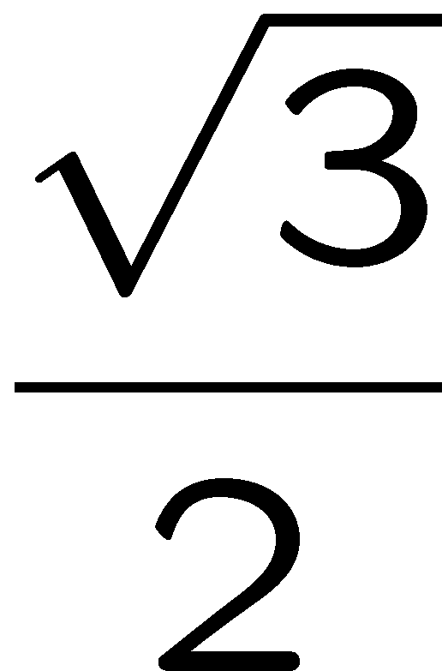than .866. You should not need a calculator for this exam.

Unless otherwise noted, assume that everything is a right-handed coordinate system and that angles are measured counter clockwise. E.g. to find the direction of rotation, point your thumb along the axis and curl your fingers.

If you need extra space, use the back of a page, but clearly mark what everything is. We may look at your work to determine partial credit.

The exam has 86 points (not 100)

Q1: __ / 6
Q2: __ / 10
Q3: __ / 12
Q4: __ / 4
Q5: __ / 12
Q6: __ / 6
Q7: __ / 5
Q8: __ / 9
Q9: __ / 12
Q10: __ / 4
Q11: __ / 3
Q12: __/ 3

Total: ___ / 86

Question 1: (6pts)
You are given a Catmull-Rom spline (a cardinal cubic with t=0) that has 5 points (P₁, P₂ P₃, … P₅). You need to convert this spline to a list of cubic Hermite segments.

1A: How many cubic Hermite segments will there be?

1B: For each of these Hermite segments, give expressions for each of its “controls.”
Note: you should explain the ordering of the control points for each segment)
Note: you should have n*4 expressions (where n is the answer to 1A)

Question 2: (10pts)
Consider a clock on the wall (Y is Up, X is to the left right). The center of the clock is at the origin, and the hands are line segments from the origin. Assume its 9:00am and the clock is correct. Also, assume that the hour hand always points at the hour (unlike a real clock where it moves continuously) – so if it were 9:30, the hour hand would still point left, and the minute hand would point down). This means that the hour hand “jumps” between hours at the end of the hour.

In the following questions the transformations only affect the hands of the clock.

Give a 2x2 matrix that:
3A) Changes the time to 12:15. (this answer is a 2x2 matrix)

3B) Changes the time to 6:15 (this answer is a 2x2 matrix)

3C) Is a rotation that changes the time to some time between 3 and 4.
(this answer is a 2x2 matrix)

3D) What is the earliest time that a correct answer to 3C could give?
(this answer is a time)

Question 3: (12 pts)

Given the following sampled signal:
[0 4 4 8 8 4 0] (the first sample is for t=0, and the second sample is t=1). Assume any sample outside of the range 0-6 is 0.

Here are two reconstruction kernels (the grid units are ¼):

3A: If kernel 1 is used to reconstruct the signal, what will the value be at:
t=1.5
t=3
t=4.5
3B: If kernel 2 is used to reconstruct the signal, what will the value be at:
t=1.5
t=3
t=4.5

Question 4: (4pts)
4A) If lightness is linearly coded between 0 and 255, is the difference between 64 and 65, or the difference between 191 and 192 more noticeable (perceptually)?

4B) In 4A, the differences were perceptually different. If the lightness was properly gamma corrected (instead of linearly coded), would this difference (between the differences) be bigger or smaller?

Question 5: (9pts)

Imagine a “shadow puppet” made by a person’s fingers, projecting onto a wall.
A lightbulb is placed a 0,5,10.
The first finger extends from 0,5,5 to 0,6,5.
The second finger extends from 5,5,1 to 5,6,1.
Everything is projected onto the wall z=0.

5A) where does the first finger project to? (where do the endpoints go)
(the answer should be the positions of 2 points)

5B) where does the second finger project to?
(the answer should be the positions of 2 points)

5C) write a 4x4 projection matrix that determines where a point (x,y,z,1) will be projected to.

Question 6: (6pts)

For each of the following 3 color systems, give an example of an application that it would be most appropriate to use it for. (pick things that the other 2 wouldn’t be as good for)

6A) CIE XYZ Color System

6B) YCC Color System (or YUV)

6C) HSV or HSL Color System

Question 7: (5pts)
Sketch the Catmull-Rom spline (Cardinal cubic with t=0) through the following points:

Question 8: (9pts)
Define each of the following terms CONCISELY:

8A) Metamer

8B) Keyframe (as the term is used in MPEG video compression)

8C) Dithering

Question 9: (12pts)

Imagine a simple OpenGL-like graphics toolkit. All of the transformation operations are like OpenGL in that there is a matrix stack and the command affect the top of it. Rotation is measured in degrees counterclockwise. For each of the little programs below, assume that the programs start out with the identity matrix on the stack.

Here is an example program and its resulting picture:
Draw Square
PushMatrix
Scale(2,2)
Translate(2,1)
Scale(-1,1)
Draw Square
PopMatrix
Rotate 90
Translate -3,0
Draw Square

9A: If we forgot the “Push Matrix” and “PopMatrix” commands in the example program, the last square would appear in a different place. Draw it on the example above.

9B: If we had forgotten the “PushMatrix” and “Pop Matrix” commands, and wanted to “reset” the transformation back to the identity at the end, we could add the following 3 lines of code. Specify what the values of A, SX, SY, TX, TY should be:

Rotate A
Scale SX, SY
Translate TX, TY

9C: Write a program that draws the following picture (with 3 squares) without using PushMatrix or PopMatrix commands. You can use any of the other commands from the example program.

Question 10: (4pts)
Which of the following are NOT part of the JPEG image compression method. (Cross out the ones that are not done in JPEG compression)

10A) The pixel values are quantized to less than 8 bits.
10B) The image is changed from RGB to another color system.
10C) Blocks of the image are transformed into the frequency domain.
10D) Each block of the image is quantized different amounts.
10E) Different frequencies of the image are quantized differently.
10F) The quantized coefficients are encoded in a lossless manner.

Question 11: (3pts)
The Painter’s Algorithm cannot handle a scene where there are two polygons that intersect.

How does a BSP tree handle them?

Question 12: (3pts)
If we use Brezenham’s line drawing algorithm to draw the lines between the points below, how many pixels will get “set”. (Note: Brezenham’s algorithm is also called the Midpoint algorithm).
Hint: you should count the beginning and end points.

11a) from (10,10) to (20,10)

11b) from (10,10), to (20,20)

11c) from (10,10) to (20,30)

