CS559 Midterm Exam
November 1, 2006

This exam is closed book and closed notes.

You will have the entire period (until 9:00pm) to complete the exam, although the exam is designed to take less time.

Please write your name and CS login on every page!

Write numerical answers in fractional form or use radicals (square root symbols) – we would prefer to see 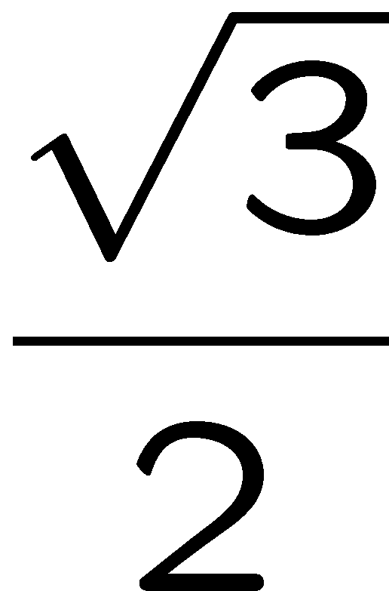than .866. You should not need a calculator for this exam.

Unless otherwise noted, assume that everything is a right-handed coordinate system and that angles are measured counter clockwise. E.g. to find the direction of rotation, point your thumb along the axis and curl your fingers.

If you need extra space, use the back of a page, but clearly mark what everything is. We may look at your work to determine partial credit.

Key: answers in blue, discussion in green
Means score on each question – at least 1 person got full points on each question
Q1: 3.7 / 6  Q2: 6.6 / 10  Q3: 10.5 / 12  Q4: 3.1 / 4  Q5: 6.9 / 12  Q6: 3.1 / 6  Q7: 6.9 / 5  Q8: 4.7 / 9  Q9: 9.2 / 12  Q10: 2.3 / 4  Q11: 2.5 / 3  Q12: 2.2 / 3 | Grading:  < 25 = F  < 40 = D  < 44 = CD  < 48 = C  < 53 = BC  < 60 = B  < 71 = AB  > 71 = A  above the mean -> AB  1 StdDev above the mean = A  worse than 1 StdDev below the mean = C  median grade = AB, mean = 3.2

Total: mean:59.0 / 86 stdev: 12, max: 82
Scores are positively correlated with P1 grades

Question 1: (6pts)
You are given a Catmull-Rom spline (a cardinal cubic with t=0) that has 5 points (P₁, P₂ P₃, … P₅). You need to convert this spline to a list of cubic Hermite segments.

1A: How many cubic Hermite segments will there be?

2 (2pts)

1B: For each of these Hermite segments, give expressions for each of its “controls.”
Note: you should explain the ordering of the control points for each segment)
Note: you should have n*4 expressions (where n is the answer to 1A)

Segment 1: CP0 (e.g. f(0)) = P2 Segment 2: CP0 = P3
CP1 (e.g. f’(0)) = ½ (P3-P1) CP1 = ½ (P4-P2)
CP2 (e.g. f(1)) = P3 CP0 = P4
CP3 (e.g. f’(1)) = ½ (P4-P2) CP3 = ½ (P5-P3)
½ point for each, -1 for not explaining what the points are

Question 2: (10pts)
Consider a clock on the wall (Y is Up, X is to the left right). The center of the clock is at the origin, and the hands are line segments from the origin. Assume its 9:00am and the clock is correct. Also, assume that the hour hand always points at the hour (unlike a real clock where it moves continuously) – so if it were 9:30, the hour hand would still point left, and the minute hand would point down). This means that the hour hand “jumps” between hours at the end of the hour.
(2 pts for each)
In the following questions the transformations only affect the hands of the clock.
The hour hand at 9am is the –X axis, the minute hand is the +Y axis
Give a 2x2 matrix that:
3A) Changes the time to 12:15. (this answer is a 2x2 matrix)
+Y axis -> +X axis 0 1
-X axis -> +Y axis -1 0
3B) Changes the time to 6:15 (this answer is a 2x2 matrix)
+Y axis -> +X axis 0 1
-X axis -> -Y axis 1 0
3C) Is a rotation that changes the time to some time between 3 and 4.
(this answer is a 2x2 matrix)
rotate –x -> +x (180 degrees) -1 0
means +Y gets rotated 180 degrees as well 0 -1
3D) What is the earliest time that a correct answer to 3C could give?
(this answer is a time)
3:30 the answer to 3C is the only rotation that maps 9->3

Question 3: (12 pts)

Given the following sampled signal:
[0 4 4 8 8 4 0] (the first sample is for t=0, and the second sample is t=1). Assume any sample outside of the range 0-6 is 0.

Here are two reconstruction kernels (the grid units are ¼):
(2pts each answer)
3A: If kernel 1 is used to reconstruct the signal, what will the value be at:
t=1.5 -.5 * 0 + .5 * 4 + .5 * 4 + -.5 * 8 = 0
t=3 8 (the kernel is interpolating)
t=4.5 -.5 * 8 + .5 * 8 + .5 * 4 + -.5 * 0 = 2
3B: If kernel 2 is used to reconstruct the signal, what will the value be at:
t=1.5 .5 * 4 + .5 * 4 = 4
t=3 .25 * 4 + .75 * 8 + .25 * 8 = 9
t=4.5 .5 * 8 + .5 * 4 = 6

Question 4: (4pts)
4A) If lightness is linearly coded between 0 and 255, is the difference between 64 and 65, or the difference between 191 and 192 more noticeable (perceptually)?
(2pts for each anwer)
64-65 since the eye perceives percentage differences

4B) In 4A, the differences were perceptually different. If the lightness was properly gamma corrected (instead of linearly coded), would this difference (between the differences) be bigger or smaller?

Less since gamma correction makes the differences the same (if you got the right explanation, but the wrong answer, get 1 pt)

Question 5: (12pts)

Imagine a “shadow puppet” made by a person’s fingers, projecting onto a wall.
A lightbulb is placed a 0,5,10.  The first finger extends from 0,5,5 to 0,6,5.  The second finger extends from 5,5,1 to 5,6,1.  Everything is projected onto the wall z=0. | 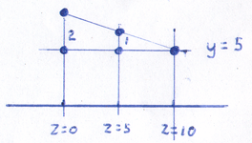

5A) where does the first finger project to? (where do the endpoints go)
(the answer should be the positions of 2 points)
0,5,0 0,7,0 (best done using a picture – see above)
(3pts, 1pt for X and Z, 1 pt for each Y)
5B) where does the second finger project to?
(the answer should be the positions of 2 points)
50/9,5,0 50/9,55/9,0 (best done using using pictures, x and y are separate)
(1 pt for X, 1 pt for each Y)
5C) write a 4x4 projection matrix that determines where a point (x,y,z,1) will be projected to:
Final Position (after divide by w): so: w’ = 10-z 10 0 0 0
X’ = x * 10/(10-z) x’ = 10 x 0 10 -5 0
Y’ = 5 + (y-5) * 10/(10-z) y’ = 10 y – 5z 0 0 0 0
Z’ = 0 z’ = 0 0 0 -1 10
Write out equations for x’, y’, z’, w’ but get matrix wrong = 4pts
Write out equations for x’, y’ z’ but not get common w = 3pts

Question 6: (6pts)

For each of the following 3 color systems, give an example of an application that it would be most appropriate to use it for. (pick things that the other 2 wouldn’t be as good for)
2pts each, get 1 pt for explaining the reason without getting an application

6A) CIE XYZ Color System
A theoretical space – useful for analyzing gamuts of devices

6B) YCC Color System (or YUV)
A perceptually uniform color space that separates out luminance
Useful for image coding (used in JPEG and TV)

6C) HSV or HSL Color System
Meant to be easier for artists, useful for artist controls
Question 7: (5pts)
Sketch the Catmull-Rom spline (Cardinal cubic with t=0) through the following points:

Through every point the curve passes, draw an arrow with the derivative to see how the curve goes
Connect 1 and/or 9 = -1 pt
Directions at the beginning and end = -1pt
Bumps on the correct side of 2-3, 3-4, 6-7, 7-8 = -1pt (-1/2 for just 1 wrong)
Crossing horizontal on 4-5 = -1 pt
Not interpolating 2-8 = -1pt

Question 8: (9pts)
Define each of the following terms CONCISELY:
3 pts each
8A) Metamer
Two different “colors” (spectral distributions) that are sensed as the same.
8B) Keyframe (as the term is used in MPEG video compression)
An image (or frame) that is send “whole” as a base so that subsequent frames can be sent as differences from it.
8C) Dithering
Using randomness (noise) to create half-toning / quantization that is less blocky.
A common misuse of the term is to have dithering mean any quantization method (even without randomness). Lose 1 point for this, lose 2 points if you said dithering was a specific quantization method that doesn’t use randomness.
Question 9: (12pts)

Imagine a simple OpenGL-like graphics toolkit. All of the transformation operations are like OpenGL in that there is a matrix stack and the command affect the top of it. Rotation is measured in degrees counterclockwise. For each of the little programs below, assume that the programs start out with the identity matrix on the stack.

Here is an example program and its resulting picture:
Draw Square
PushMatrix
Scale(2,2)
Translate(2,1)
Scale(-1,1)
Draw Square
PopMatrix
Rotate 90
Translate -3,0
Draw Square

9A: If we forgot the “Push Matrix” and “PopMatrix” commands in the example program, the last square would appear in a different place. Draw it on the example above.
2pts

9B: If we had forgotten the “PushMatrix” and “Pop Matrix” commands, and wanted to “reset” the transformation back to the identity at the end, we could add the following 3 lines of code. Specify what the values of A, SX, SY, TX, TY should be:

Rotate A A = -90
Scale SX, SY SX = -1/2, SY = 1/2
Translate TX, TY TX = -4, TY=4
1 point for each number correct
9C: Write a program that draws the following picture (with 3 squares) without using PushMatrix or PopMatrix commands. You can use any of the other commands from the example program.
Note: there are many possible answers, this is just one:

translate(5,0);
draw Square();
translate(-2,0);
scale(2,2);
draw Square();
scale(1.5,1.5);
translate(-1,0);
draw Square();

5 pts total. Small penalty for “silly” mistakes (like leaving off the last drawSquare();
1 pt for each correct translate (to be correct, it has to scale correctly)
1 pt for the second and third scales

Question 10: (4pts)
Which of the following are NOT part of the JPEG image compression method. (Cross out the ones that are not done in JPEG compression)
(-1 not crossing out what should be crossed out, -1/2 for crossing out something that shouldn’t be)
Cross out the wrong answers
10A) The pixel values are quantized to less than 8 bits.
Pixel values aren’t quantized, the dct coefficients are
10B) The image is changed from RGB to another color system.
To YUV in fact
10C) Blocks of the image are transformed into the frequency domain.
Using the DCT
10D) Each block of the image is quantized different amounts.
Each block is quantized the same way
10E) Different frequencies of the image are quantized differently.
Different frequencies are allocated more or less bits
10F) The quantized coefficients are encoded in a lossless manner.
Using Huffman coding, delta coding and RLE coding, in fact

Question 11: (3pts)
The Painter’s Algorithm cannot handle a scene where there are two polygons that intersect.

How does a BSP tree handle them?
It splits one of the polygons so it doesn’t cross the plane of the other.
-1 for saying splitting both polygons, rathern than splitting one

Question 12: (3pts)
If we use Brezenham’s line drawing algorithm to draw the lines between the points below, how many pixels will get “set”. (Note: Brezenham’s algorithm is also called the Midpoint algorithm).
Hint: you should count the beginning and end points.

11a) from (10,10) to (20,10) 11

11b) from (10,10), to (20,20) 11

11c) from (10,10) to (20,30) 21

-1 for consistent off-by-one error

