Part 2:

5. Since the training set is drawn at random, consecutive execution of the program produces somewhat different learning curves. The following are two of the curves produced for the average (blue), min (red) and max (green) accuracies:

Accuracy

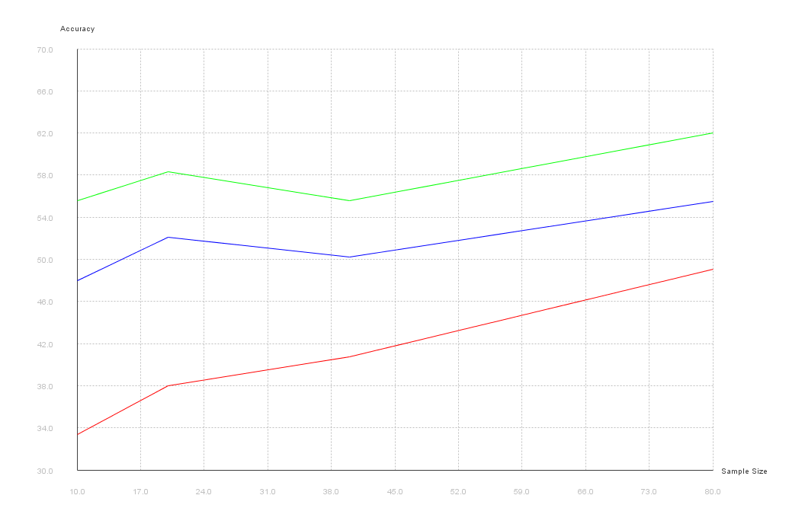

Training Set size

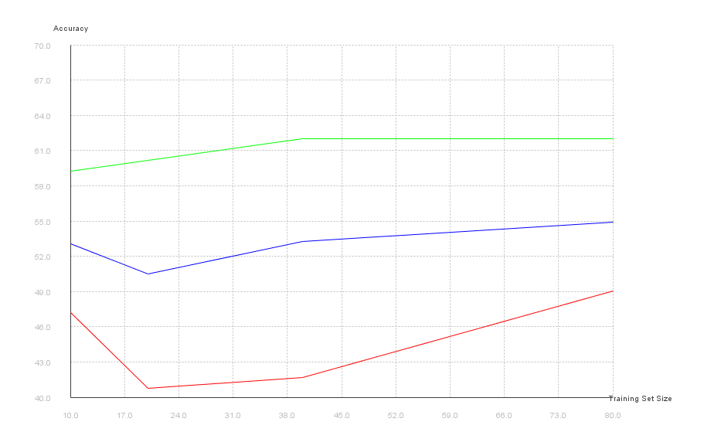

Accuracy

Training Set size

6.

